“RESUME BUILDER”

Mini Project

Submitted in partial fulfillment of the requirement of University of Mumbai

For the Degree of

(Computer Engineering)

By

1. “ROHINI RAI” “ID No: TU3F2021141”
2. “RUCHIKA NAIK” “ID No:TU3F2021162”
3. “MANASI CHAVAN” “ID No:TU3F2021013”

Under the Guidance of

Prof. “UJWALA GAIKWAD”

Prof. “VISHWAJIT GAIKWAD”



Department of Computer Engineering

TERNA ENGINEERING COLLEGE

Plot no.12, Sector-22, Opp. Nerul Railway station,

Phase-11, Nerul (w), Navi Mumbai 400706

UNIVERSITY OF MUMBAI



Terna Engineering College

NERUL, NAVI MUMBAI

CERTIFICATE

*This is to certify that*

1. “ROHINI RAI” “ID No: TU3F2021141”
2. “RUCHIKA NAIK” “ID No:TU3F2021162”
3. “MANASI CHAVAN” “ID No:TU3F2021013”

*Has satisfactorily completed the requirements of the Mini Project*

*Of subject*

“Skill based Lab Course: Object Oriented Programming with Java”

*As prescribed by the University of Mumbai Under the guidance of*

Prof. “UJWALA GAIKWAD”

Prof. “VISHWAJIT GAIKWAD”

**HOD**

**Subject Incharge**

Index

|  |  |  |
| --- | --- | --- |
| TABLE OF CONTENTS | | |
|  |  |  |
| Caption |  |  |
| Chapter 1 | Introduction |  |
| Chapter 2 | Problem Statement |  |
| Chapter 3 | Implementation |  |
| Chapter 4 | Conclusion |  |
|  | Reference |  |

Chapter 1

Introduction

Our mini project is a “RESUME BUILDER” , as the need of this kind of application is highly required in recent times , so keeping this in mind we decided to create this application which will help a lot of people to build their resume. A resume is an important tool for your job search because it offers a page or two where you can display your top skills and qualities. Resumes help employers make hiring decisions and help you get your first interview. That's why, we created this application because, it matters how you structure your resume and what information you decide to include.

It is an application that simplifies the task of creating a resume for individuals. The system is flexible to be used and reduces the need of thinking and designing an appropriate resume according to qualifications. The system is developed to provide an easy means for creating a professional looking resume. Individuals just have to enter their details directly into the pop-up box and their resume will be created automatically. A well-structured resume will be generated, once the user submits his/her details and user can download it in any file format, as per his/her requirement.

In order to develop this application, we have used JAVA language . Java GUI makes computer operation more user friendly that is easier to use and learn. Java GUIs gives the java users an immediate and visual feedback about the effect of each action. Java GUIs enables multiple instances or even programs to be displayed simultaneously. The IDE which we have used is an ECLIPSE IDE ,to develop this system. In order to provide the look and feel to our GUI , we have used the concepts like SWING and AWT. We have also used other important packages of java like io and AWT’s Graphics method ,event, print method and SWING’s JFileChoose method etc.

Chapter 2

Problem Statement

Working of the Application:-

This application consists of certain pages , in the process of resume generation we have to jump from one page to next page and after reaching on the final page we can save it and our resume gets generated and then we can print our resume in any format.

So first page is the landing page which consists of two option , 1] login and 2] sign up. If the user is new so he/she can sign up , so the username and password gets generated . The sign up page leads us to the login page , where user can enter their previously generated username and password . After successfully login , login page will lead user to an another interface were user can enter their personal details like name , dob , phone number , etc. . After this the next interface will appear where user can enter their education details and all. This education interface will take user to the next interface where experience and skills can be entered. And after all this , all the previously entered information from all the interfaces gets reflected on the final page where we can save it and then take print of that resume in any format.

For user name and password generation we have used the concept of “FileWriter” which is present in the java’s “ io ” package.

For selecting image from our device we have used the concept of “JFileChooser” which is present in java’s “swing” package.

For printing the resume we have used the concept of “Graphics” and “print” which is present in the Java’s “awt” package.

* We also made an exe installer of this java application. We converted “ .jar ” file to “.exe ” so that we can share this application with others and they can install it on their device.
* For converting “.jar” into “.exe” and making it available for installation we used two softwares ,
  + 1. Launch4j 🡪 To create an .exe file.
  + 2. Inno Setup Compiler 🡪 builds our application folder and generates “.exe” setup , so that anyone can install it.

## **EXISTING SYSTEM**

If someone wants to make his/her resume, then he/she have to look for every single detail such as formatting, alignment, designs, patterns. So, it is a very complex process and thus, the productivity of the resume also decreases. The existing system is very complex and making resume via word files and excels is a tough task. Sometimes, while making a resume, a person ends up forgetting some very crucial information while going through all these designs and formats.

## **PROPOSED SYSTEM**

In the proposed resume builder , a person has to only fill the details which is already prepared in this application . All the other alignments and formats of the resume are being directly taken care of by the system. Even, the final resume which came out is very professional as per the industry requirement and the candidate can download the resume as per the file format he/she requires. This avoids need of putting manual effort for creating resume.

Chapter 3

Implementation

1. Landing page:-

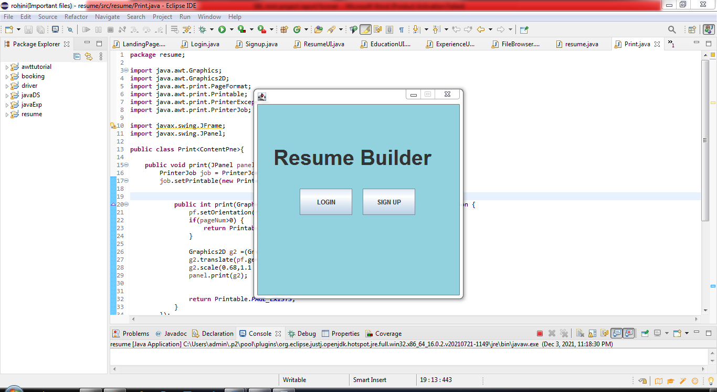

2. Sign up page:-

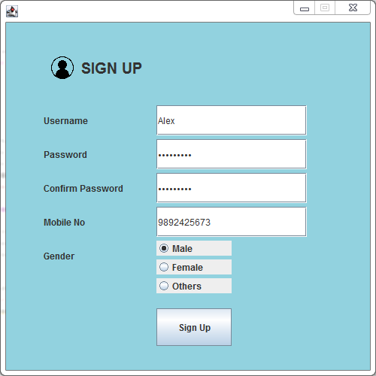

3. After Sign up .txt file gets generated which consists of the username and password.

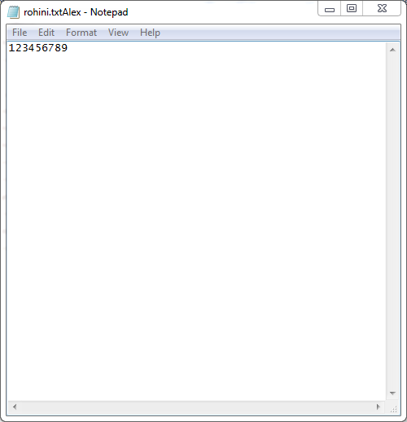

4. Login page:-

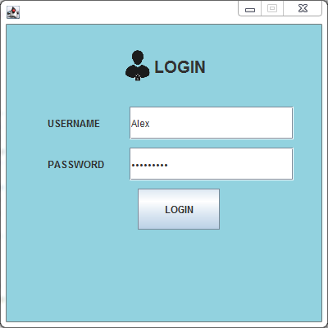

5. Personal detail page:-

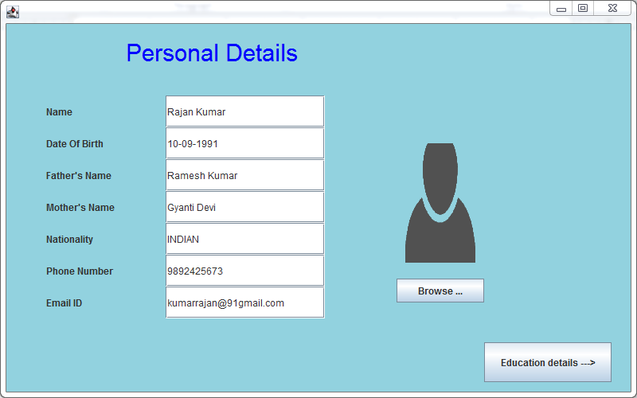

5.1. After clicking on browse option dialog box appears to browse profile picture from device.

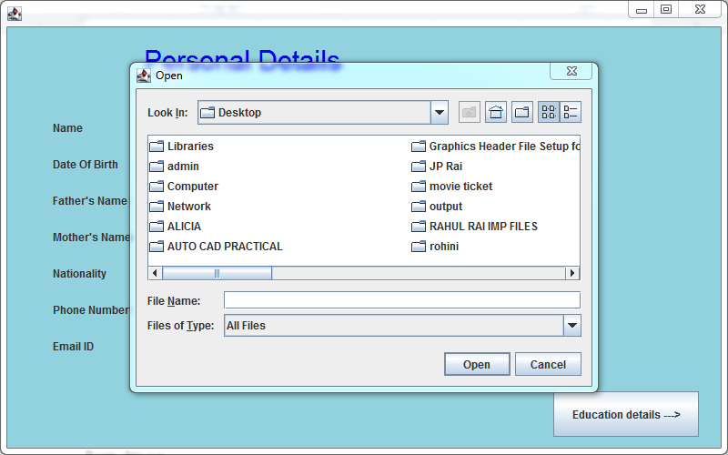

5.2. After selecting photo:-

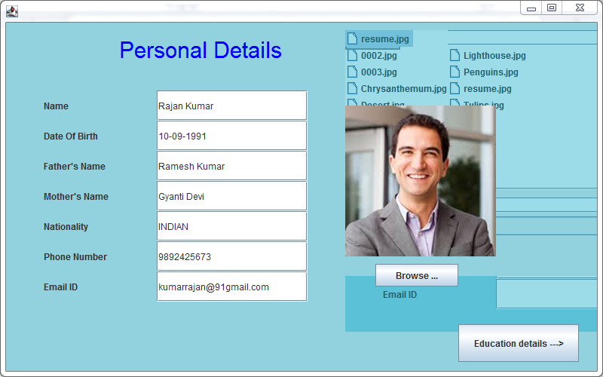

6. Education detail page:-

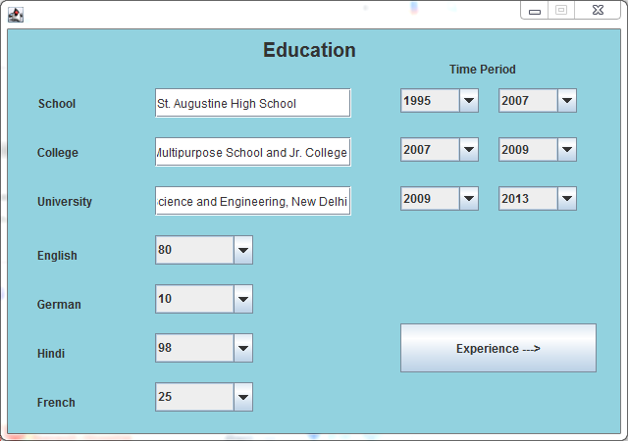

6. Experience page:-

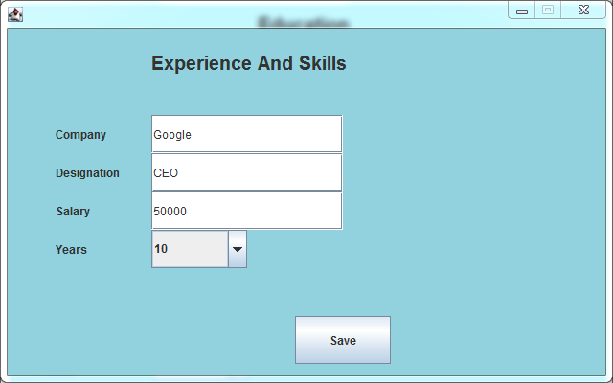

7. Resume gets generated:-

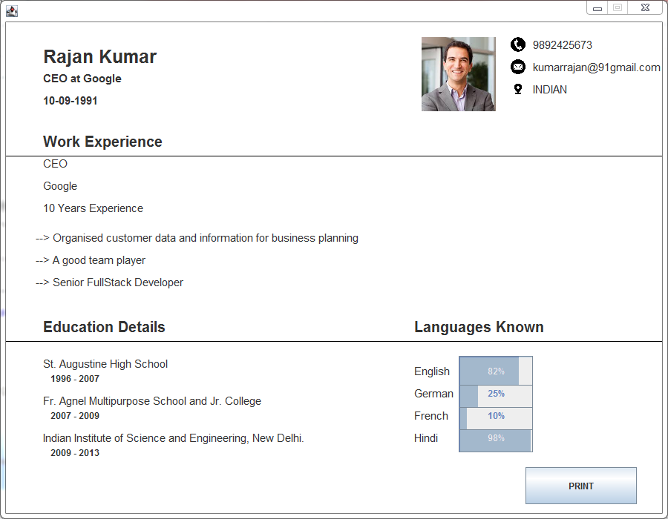

8. Dialog box appears after clicking on print option:-

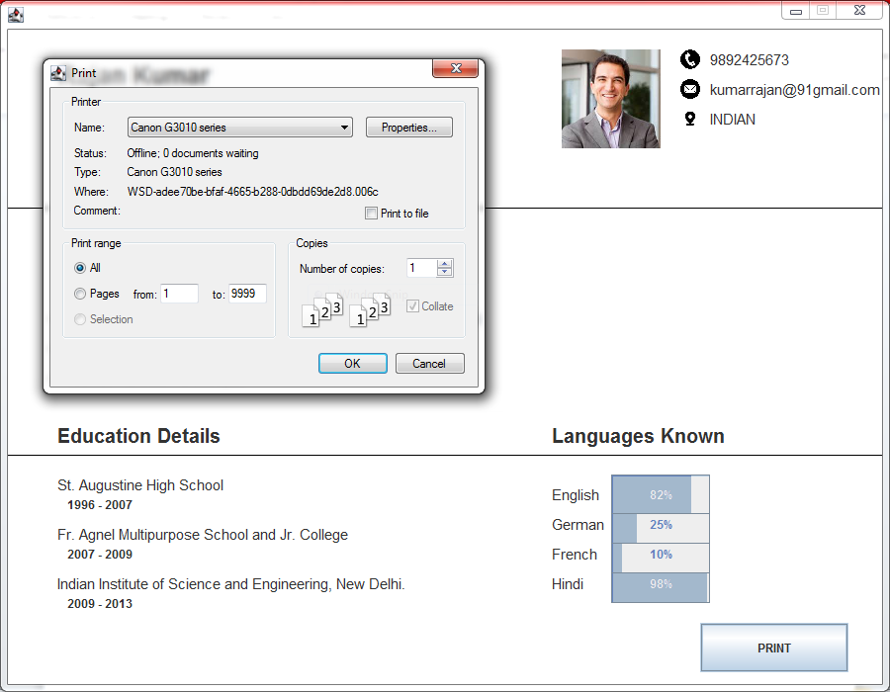

9. After taking print:-

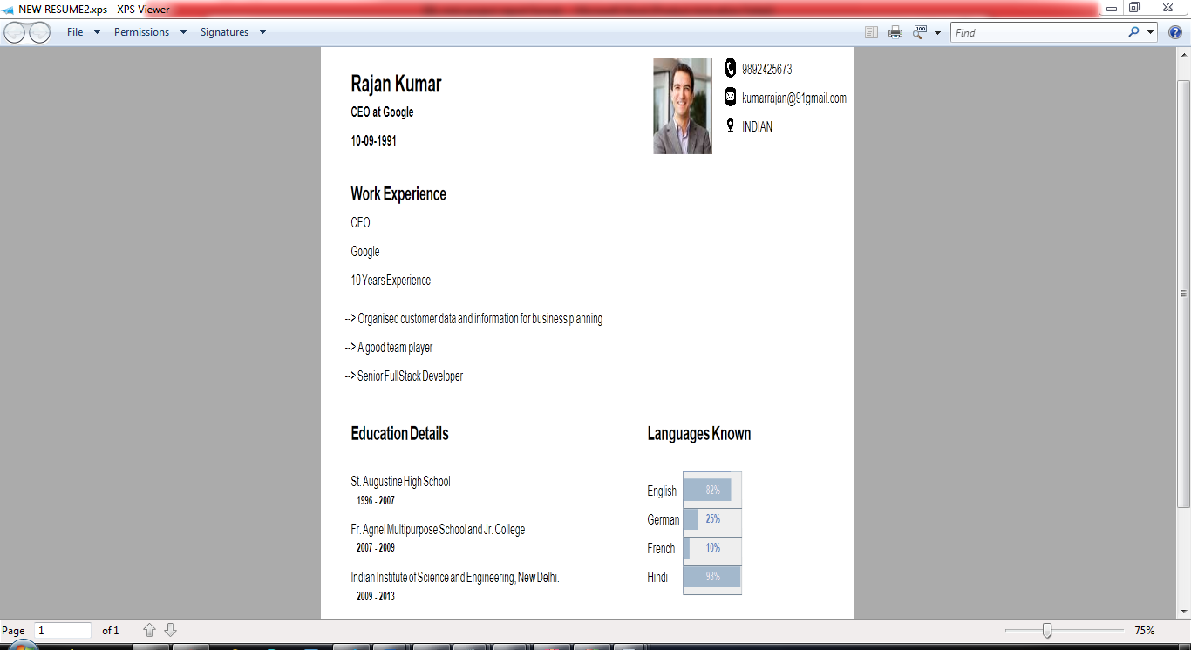

10. .exe setup

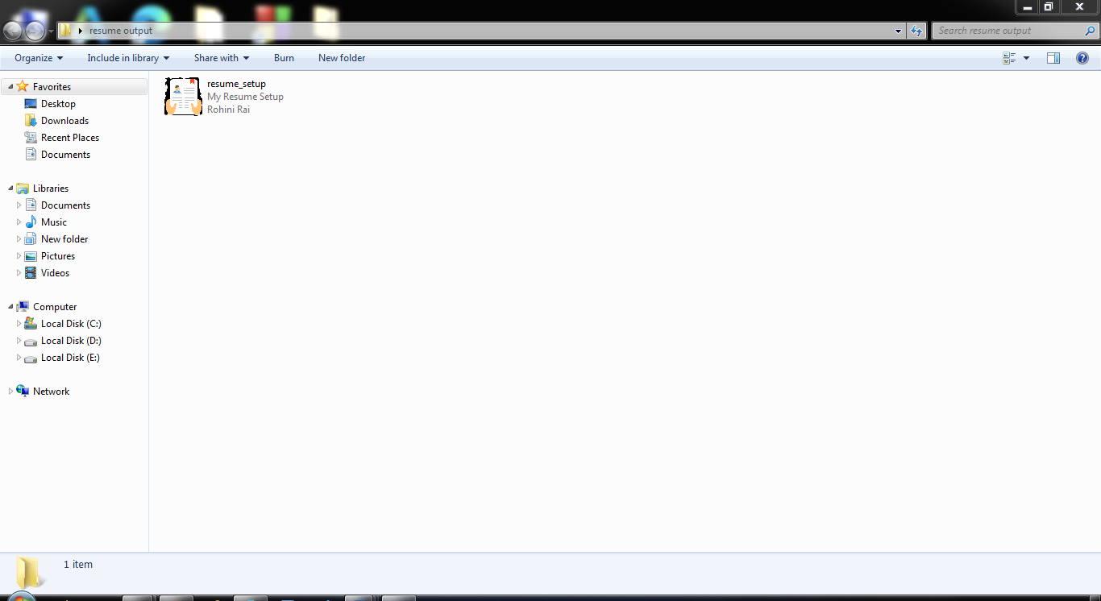

11. After installation it appears on desktop

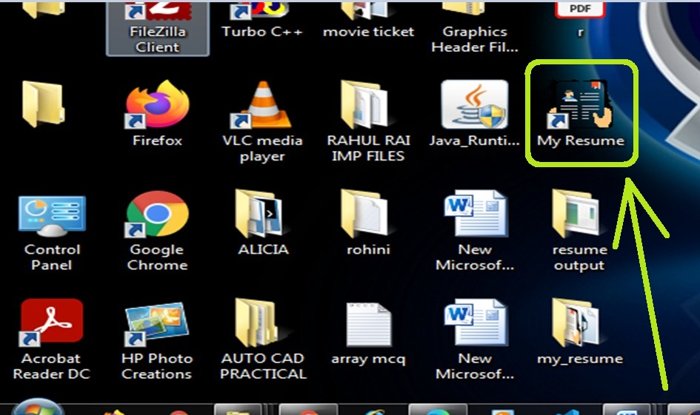

Chapter 4

Conclusion

This resume builder is one of the most fantastic systems for the people who are either freshers in their domain or if they don’t have enough idea about the resume or don’t have enough time to create the resume of good designs or patterns, then this application is a very productive place for them. It saves a lot of time and cost-effective.

This application can be provided by any college or university to their students so that they can create their resume without being tensed about the design and inputs. And create their resume in an effective way by saving their time.

Advantages of this application:-

* Provides instant resume to individuals.
* There are choices available for resume format for users as per their qualification and requirements.
* Reduces tedious work in thinking and creating resume and is convenient for users.
* Provides quick access and is affordable.
* The system saves time and reduces human efforts.

Reference

* “JAVA The Complete Reference”, by Herbert Schildt
* “Programming with Java”, by E Balagurusamy.
* [Websites :-](https://www.googleadservices.com/pagead/aclk?sa=L&ai=DChcSEwjYkKiTmuzzAhVWDisKHctUArwYABAAGgJzZg&ae=2&ohost=www.google.com&cid=CAESQeD2PiU8Vn_VuaiqPdRP4YswSPvWmjNHj7nXdIPIHZcDepLzoa91cVtwoMvZJZdp03BB0ME1NTffzf0gZlC7q0-_&sig=AOD64_0kEWBb356kn4IVui9soZd4Inf38w&q&adurl&ved=2ahUKEwihvJaTmuzzAhVB8HMBHbDTDgUQ0Qx6BAgCEAE)

1. GeeksForGeeks

<https://www.geeksforgeeks.org › java>

1. [Javatpoint](https://www.googleadservices.com/pagead/aclk?sa=L&ai=DChcSEwjYkKiTmuzzAhVWDisKHctUArwYABAAGgJzZg&ae=2&ohost=www.google.com&cid=CAESQeD2PiU8Vn_VuaiqPdRP4YswSPvWmjNHj7nXdIPIHZcDepLzoa91cVtwoMvZJZdp03BB0ME1NTffzf0gZlC7q0-_&sig=AOD64_0kEWBb356kn4IVui9soZd4Inf38w&q&adurl&ved=2ahUKEwihvJaTmuzzAhVB8HMBHbDTDgUQ0Qx6BAgCEAE)

[https://www.javatpoint.com › java-tutorial](            https://www.javatpoint.com › java-tutorial)

1. Oracle

[https://www.oracle.com › java](https://www.oracle.com/in/java/)

1. W3SCHOOLS

<https://www.w3schools.com › java>

1. Tutorialspoint

<https://www.tutorialspoint.com › java>